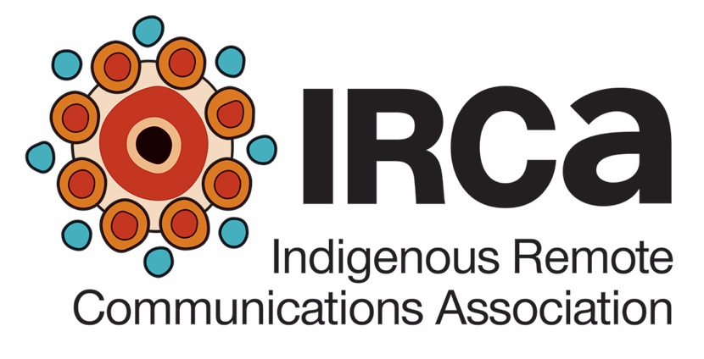
For Director Elections May 2017
Board of Directors Nomination Information Guide
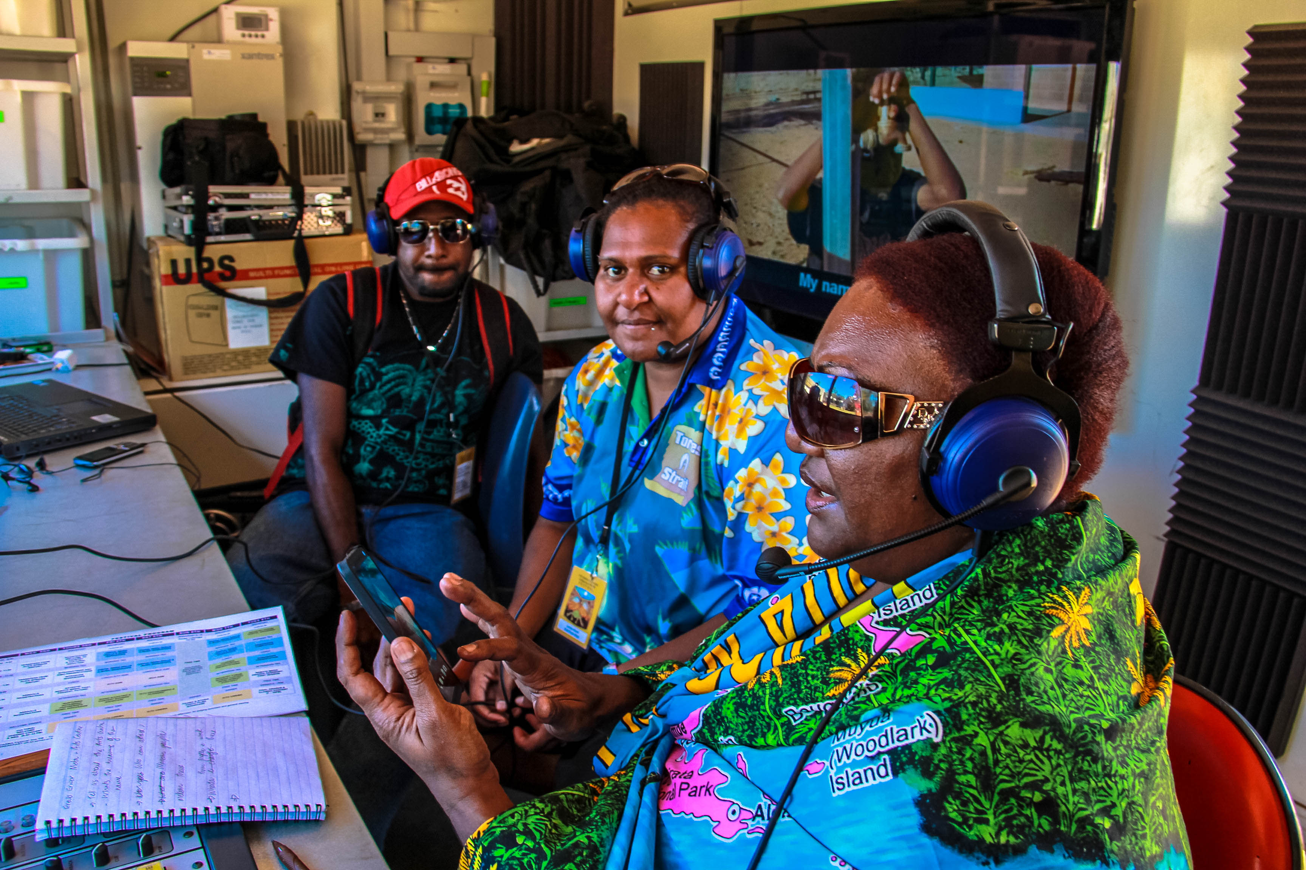
Indigenous Remote Communications Association
Level 2 70 Elder Street (PO Box 2731)
ALICE SPRINGS NT 0870
P 08 8952 6465 E manager@irca.net.au
W www.irca.net.au

Key points | Key dates
- Only Ordinary Members can nominate persons for the IRCA Board.  - Only Ordinary Member Representatives and Associate Members can be nominated to the Board.  - Nominations are to be made using the Board of Director Nomination Form.  - Only Ordinary Member Representatives may vote. Each Ordinary Member has one vote.  - The IRCA Board comprises a maximum of 9 members and a minimum of 5 members. Up to another 3 Aboriginal and Torres Strait Islander non-members can be included by the Board to bring specialist skills.  - The IRCA Board aims to meet diversity goals as well as include skills and experience important for the development of the industry. | Director nomination and election  - Nominations OPEN on 10 April 2017 and are to be submitted using the IRCA Board of Directors Nomination Form.  - Nominations CLOSE at 5pm Central Standard Time on 26 April 2017  - The list of nominees is provided to Ordinary and Associate members on 3 May 2017  - Voting by Ordinary Members takes place at the Special General Meeting of 24 May 2017.  Ordinary and Associate Membership Application Approval  - IRCA Board Meeting on or before 24 April 2017 will consider approval of latest applications for membership.

What is in this Guide?

1. Introduction 3
2. Board structure and Director numbers 3
3. Director Term of Appointment 3
4. Nominating a member for Director 4
5. Eligibility for Director nomination 4
6. Waiving of 12-month eligibility 5
7. Nominee profiles 5
8. Voting for Directors 5
9. Proxies 5
10. Nominations from applicant Ordinary Members not yet reviewed at an IRCA Board Meeting 6
Further information 6
Appendix 1: Current Ordinary Members 7
Appendix 2: Board Skills and Resource Focus Areas 8

1. Introduction

The nomination and election of Directors to the Indigenous Remote Communications Association (IRCA) Board of Directors is governed by the IRCA Constitution.

The Constitution is available from the IRCA website at http://www.irca.net.au/publications/irca. Relevant Clauses are:

- Clause 3.1.1 Ordinary Membership eligibility
- Clause 3.1.2 Associate Membership eligibility
- Clause 6 (all sub clauses) Directors
- Clause 6.2 Eligibility of Directors
- Clause 6.4 Board diversity
- Clause 6.5 Election of Directors
- Clause 6.6 Director’s term of appointment

2. Board structure and Director numbers

The structure of the Board is provided as a document with this Nomination Information Guide. The IRCA Constitution sets out a maximum of 9 Directors and a minimum of 5 Directors. The attached document sets out the composition of the Board according to location, diversity and skills.

3. Director Term of Appointment

Under Clause 6.6.1 of the IRCA Constitution, Directors are appointed for a rotation term of two years, with half of the positions up for election each year. Clause 6.6.4 outlines how the rotation system is to be implemented, with half of the first group of Directors appointed for one year at the IRCA AGM and the other half for two years. IRCA’s AGM will be held about October-November each year, with the first AGM under the new Constitution scheduled for 9 November 2017.

However, the implementation of these two clauses is shaped by the decisions of members at the Special General Meeting of 27 September 2016. That decision being that all Board Directors stand down at the Special General Meeting at the May 2017 National Summit with elections for all Directors under the new Constitution to take place at that meeting. This provides only a 6-month period before the November AGM.

Accordingly, a resolution will be put to the Special General Meeting of 24 May 2017 that:
- The next scheduled Board elections be held in November 2018, except that where Board vacancies need to be filled, elections for those vacancies will be held at the November 2017 AGM, and
- That the new Board of Directors prepare a recommendation to be put to IRCA membership at the November 2017 AGM as to how the Director rotation will be implemented such that half of the Director positions are put forward for election in November 2018.

4. Nominating a member for Director

Nominations are to be made using the Board of Directors Nomination Form. Only Ordinary members can nominate a member for a Director position. Members who can be nominated are:

- Representatives of Ordinary Members as per Clause 6.2.1.4 of the IRCA Constitution
- Associate Members as per Clause 6.2.1.4 of the IRCA Constitution

Two Ordinary Members are required for Board of Director nominations. The Representatives of the relevant Ordinary Member organisations, as advised to IRCA, are the signatories for nominations. Current Ordinary Members are listed in Appendix 1 of this Guide.

Where timeliness of meeting a Nomination submission deadline is an issue, the Seconding documentation may be provided separately using the Board of Directors Nomination Seconding Form. Where the separate Seconding Form is used, both Nomination forms must be received by IRCA by the closing time and date in order for a Nomination to be accepted.

Applicants for Ordinary Membership that have not yet had their application reviewed by the IRCA Board, should read paragraph 9 of this Guide for information on how they can make a nomination.

5. Eligibility for Director nomination

Director Eligibility is set out in Clause 6.2.1 as follows:

6.2.1 Each Ordinary Member may nominate for the position of Director, someone who:
6.2.1.1 Is at least 18 years old
6.2.1.2 Is an Aboriginal and Torres Strait Islander person
6.2.1.3 Is not an employee of the Corporation (that is IRCA)
6.2.1.4 Is to be an Ordinary Member Representative or an Associate Member as under Clause 3.1.2.1
6.2.1.5 Has the skills and aptitude required to fulfill the position of Director as may be set out in a policy approved at an AGM
6.2.1.6 Has demonstrated a sound understanding of the Corporation and its activities and a commitment to the Objects of this Constitution and
6.2.1.7 Has been:
6.2.1.7.1 An Ordinary Member Representative or Associate Member as under Clause 3.1.2.1 for a cumulative period of at least one year prior to their nomination as a Director; or
6.2.1.7.2 For an Ordinary Member Representative or an Associate Member as under Clause 3.1.2.1 nominated within the twelve month period following the transition date, an Ordinary or Associate Member of the Corporation for a cumulative period of at least one year including periods before and after the transition date.

6.2.2 A majority of Directors of the Corporation must usually reside in Australia.
6.2.3 At least 50% of Directors must be drawn from organisations that serve remote Aboriginal and Torres Strait Islander communities.

6. Waiving of 12-month eligibility

Due to the 24 May 2017 election being the election of the inaugural Board under the Constitution of IRCA approved in late September 2016, the 12-month eligibility is not able to be implemented effectively. A resolution will be put at the 24 May 2017 Special General Meeting to formally waive this requirement for the inaugural Board election only.

7. Nominee profiles

Nominees may include information on the Board of Director Nomination Form, about their skills, experience, qualifications, and other information that indicates their suitability for a Director position.

In providing information on skills, experience and qualifications, Nominees are advised to check the IRCA Board’s skills and resource focus areas. The focus areas are included in Appendix 1 to this Information Guide.

Holding of skills, qualifications and experience in the focus areas is not mandatory for nomination of an Ordinary or Associate Member.

8. Voting for Directors

Voting for Director positions is only by the nominated Representative of an Ordinary Member. An Ordinary Member has one vote. The Chair has a casting vote.

Voting takes place at a General Meeting according to Clause 5.8 of the IRCA Constitution.

9. Proxies

In accordance with Clause 5.10 of the IRCA Constitution, a proxy may be appointed for Ordinary Members unable to attend a General Meeting. Proxies are to be notified at least 48 hours prior to a General Meeting to IRCA. A proxy may not represent more than 2 Ordinary members. Further information and a Proxy Form will be provided with the Notice of General Meeting on 3 May 2017.

10. Nominations from applicant Ordinary Members not yet reviewed at an IRCA Board Meeting

10.1 Applicants for Ordinary Membership whose applications have been lodged with IRCA but not yet been reviewed by the IRCA Board may nominate a person to the Board as per the eligibility specifications set out above in paragraph 4. Such nominations will be classified as “Conditional” until such time as the Board at a meeting on or before 24 April 2017 is able to review the application status of the the nominating Ordinary Member(s). Where the application is approved the nomination will be included with the nominations of current approved Ordinary Members (see Appendix 1 for a list of current Ordinary Members).

10.2 Organisations making new application for Ordinary Membership up to 21 April 2017 may also make nominations as per the arrangements under paragraph 9.1 above.

Further information

Jennifer Nixon Daniel Featherstone
Assistant Manager Manager
E asstmgr@irca.net.au E manager@irca.net.au

Indigenous Remote Communications Association
P 08 8952 6465

Appendix 1: Current Ordinary Members

As approved by the IRCA Board of Directors meetings of 13/12/2016 and 1/3/2017.

- Broome Aboriginal Media Association Aboriginal Corporation
- Derby Media Aboriginal Corporation (6DBY)
- Goolarri Media Enterprises Pty Ltd
- Ngaanyatjarra (Ng) Media
- Noongar Media Enterprises (Noongar Radio)
- Pilbara and Kimberley Aboriginal Media (PAKAM)
- Pintubi Anmatjere Warlpiri (PAW) Media
- Pitantjatjara Yankunytjatjara (PY) Media Aboriginal Corporation
- Puranyangu Rangka-Kerrem (6PRK)
- Torres Strait Islander Media Association Inc (TSIMA)

Current applicants for Ordinary Membership whose application was received on or after 1 March 2017, should read paragraph 10 of the Information Guide about lodging a nomination.

Organisations that propose to make application for Ordinary Membership prior to the closing of applications on 26 April 2017, should also refer to paragraph 10 of the Information Guide if they wish to nominate a person to the IRCA Board.

Appendix 2: Board Skills and Resource Focus Areas

Area | Focus areas
Language and culture | - Maintenance and strengthening of Aboriginal and Torres Strait Islander languages and cultures through media activities and productions.  - Supporting the protection of Indigenous Cultural and Intellectual Property rights as relevant to media and communications.
Member services | - Service provision to IRCA members to meet member needs
Radio content development and sharing | - Resources and capacity available to Aboriginal and Torres Strait Islander radio broadcasters and producers.  - Aboriginal and Torres Islander media distribution options and channels for strengthening and expanding the reach of Aboriginal and Torres Strait Islander radio.
Screen development | - Resources and capacity available to Aboriginal and Torres Strait Islander screen producers, including multimedia producers.  - Aboriginal and Torres Islander media distribution options and channels for strengthening and expanding the reach of Aboriginal and Torres Strait Islander screen content, including content for IT device screens.
Technical & convergence | - Technology strengthening as well as innovation in broadcasting, communications and media production.  - Digital convergence relevant to media production and distribution.
Training and employment | - Expansion of quality training provision to the Aboriginal and Torres Strait Islander not-for-profit media industry, including current and emerging skills areas.  - Expansion of employment and the growth of employment pathways within the Aboriginal and Torres Strait Islander not-for-profit media and communications industry.
Industry events | - Running of industry events to support IRCA’s representation and advocacy of the Aboriginal and Torres Strait islander not-for-profit media and communications industry.
Marketing and promotions | - Marketing and promotion of the Aboriginal and Torres Strait Islander not-for-profit media industry within IRCA’s representation and advocacy role.  - Marketing and promotion of IRCA.
Business development | - Capacity growth in the Aboriginal and Torres Strait islander not-for-profit media industry to source diverse income streams where appropriate.  - Capacity growth in IRCA to source diverse income streams where appropriate.
Digital inclusion | - Digital literacy development for Aboriginal and Torres Strait islander communities and peoples.  - Internet connectivity, broadband and mobile telephony rollouts and improvements for Aboriginal and Torres Strait islander communities to enable connection to relevant media services.
Policy and research | - Development of policy to support and expand the Aboriginal and Torres Strait Islander not-for-profit media and communications industry.  - Development of quality research to underpin IRCA’s representation and advocacy work.
Legal & regulatory | - IRCA compliance with relevant legislation and regulations.  - Legal service scope as part of IRCA member services.

