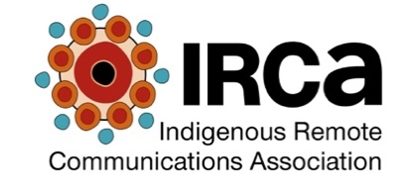

Call for Expressions of Interest in Membership of
IRCA Advisory Groups

Expressions of Interest are invited from persons working in the Aboriginal and Torres Strait Islander broadcasting, media and communications industry for membership of the IRCA Advisory Groups.

For background see the IRCA Advisory Group Terms of Reference provided with this EOI.

Closing date Friday 8 December 2017.

Advisory Group for which you are nominating (please tick) | Radio Content Sharing | Employment and Skills
Your details
Your name
Your organisation
Your organisational position
Your email address
Your daytime contact phone
Do you identify as Aboriginal and Torres Strait Islander?
Your experience and qualifications
How long have you been working in the Aboriginal and Torres Strait Islander broadcasting and media industry?
Please list any qualifications (name of qualification, educational institution, date completed) relevant to the Advisory Group
Please describe your experience relevant to the Advisory Group
Please provide any further information on experience or training relevant to your nomination
Please indicate your understanding of the role of the Advisory Board member by signing this form.

Where selected I understand that:
- Participation in Advisory Groups is volunteer based. There is no recompense for involvement in the Advisory Groups.
- Advisory Group members will be recognised in relevant IRCA communications and documents which are connected with the working of Advisory Groups.
- Advisory Group members are expected to be able to be involved on a regular basis in meetings (via teleconference) of Advisory Groups.

Signed

Date

Please return this form by cob 8 December 2017 to:

Daniel Featherstone
General Manager IRCA
E manager@irca.net.au
P 08 8952 6465
Fax 08 8992 9669

